**2.1** **Product Perspective**

***<Describe the context and origin of the product being specified in this SRS. For example, state whether this product is a follow-on member of a product family, a replacement for certain existing systems, or a new, self-contained product. If the SRS defines a component of a larger system, relate the requirements of the larger system to the functionality of this software and identify interfaces between the two. A simple diagram that shows the major components of the overall system, subsystem interconnections, and external interfaces can be helpful>***

The idea about this product is to reduce the hardship of customers standing in queues to collect the ticket for matches. This product is a follow on member of ticket reservation system available in different stadiums that have websites and online ticket reservation system. But, our product is anonymous and is not monitored or governed by any specific stadiums ticket management system. Our product is a self-contained product. Here, the user will have to scroll through the list of matches available and select a match to reserve the stadium ticket for the selected game.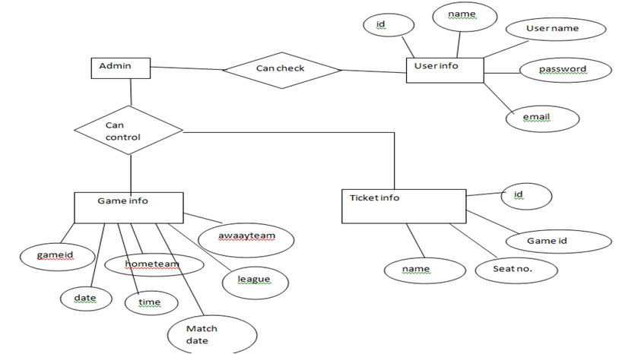

**2.2 Product Functions**

***<Summarize the major functions the product must perform or must let the user perform. Details will be provided in Section 3, so only a high level summary (such as a bullet list) is needed here. Organize the functions to make them understandable to any reader of the SRS. A picture of the major groups of related requirements and how they relate, such as a top level data flow diagram or object class diagram, is often effective.>***

·        The stadium management system software offers the user to primarily create an account by signing up in the software.

·        The user will need a Full Name, User Name, Email and Password to create the account.

·        Once the account is created, the user can Log In the software and the homepage will be displayed.

·        In the homepage, the user will be notified about the next match and upcoming matches.

·        Each game is identified by a unique game code so that one game is not mixed with the other game.

·        The user can enter the game code and book the ticket.

·        To book the game ticket, the user will need few data to be filled up like Home team, Away team, League, Match Date, Time.

·        After the booking, a dialogue box will appear where the user’s booked tickets will be displayed.

·        The user can also search for other games once after booking the ticket.

**2.3 User Classes and Characteristics**

***<Identify the various user classes that you anticipate will use this product. User classes may be differentiated based on frequency of use, subset of product functions used, technical expertise, security or privilege levels, educational level, or experience. Describe the pertinent characteristics of each user class. Certain requirements may pertain only to certain user classes. Distinguish the most important user classes for this product from those who are less important to satisfy.>***

There will be a big variety of users of this software because in the last decade, the popularity of football has reached its peak. So, according to the scenario, it is better to anticipate the users will be of different classes.

To be specific about users, there can be few characteristics on which the users can be differentiated. Few examples are-

·        Frequency of use

·        Subset of product function used

·        Technical expertise on the booking procedure

·        Security details and privileges offered

·        Educational level of user

·        Experience in software of this class

Now, based on the different classes of users, there should be few characteristics of the software that needs to be taken into consideration. Though, there might be several common reasons for different user classes but the most prominent are-

·        The software should be effective and efficient so that it doesn’t fade its performance when subjected to frequent uses.

·        The software needs to be user friendly and easy to access.

·        The features should be easy to understand and access.

·        The software should be secured so that the users don’t have any complains with their account’s privacy.

·        The software should feature easy and understandable English so it is not complicated to users with medium or below educational standard.

·        The software should make the users feel comfortable and should be similar to other booking service software so that the users can connect the dots.

Lastly, the most important customers of this product will be the average and above average spectators who are more than capable to afford the ticket fare for the matches. And those customers are most likely to be efficient in using this kind of products, should be easily able to access the credentials required for this product. And to be specific, all the classes of people in respect to age classes will fall for this product because nobody in this era would like to waste their time standing in queues to collect their tickets for their desired matches.

**2.4 Operating Environment**

***<Describe the environment in which the software will operate, including the hardware platform, operating system and versions, and any other software components or applications with which it must peacefully coexist.>***

The product we are designing will operate in the online environment. The user needs to be connected to the internet service to see the list of matches available. The user can use the product on the following hardware platforms:

a)     Desktop

b)     Laptop

c)      Mobile phone

The operating systems compatible with our product will be extensive. Like:

a)     Windows

b)     Android

c)      MacOS

**2.5** **Design and Implementation Constraints**

***<Describe any items or issues that will limit the options available to the developers. These might include: corporate or regulatory policies; hardware limitations (timing requirements, memory requirements); interfaces to other applications; specific technologies, tools, and databases to be used; parallel operations; language requirements; communications protocols; security considerations; design conventions or programming standards (for example, if the customer’s organization will be responsible for maintaining the delivered software).>***

There will be few major considerations that need to be addressed as a developer while designing the product. There will be issues like two user can book the ticket at the same time, there can be controversies where the ticket will be confirmed, so, these kinds of problems are to be addressed. The database created has to be much advanced so that whenever there is a rush, the database can handle the immense pressure. The memory allocation has to be efficient so that the system don’t get interrupted during the service. The design has to be attractive so that the user can find interest while operating the software.

**2.6            User Documentation**

***<List the user documentation components (such as user manuals, on-line help, and tutorials) that will be delivered along with the software. Identify any known user documentation delivery formats or standards.>***

The software will be very user friendly which will need no online help or tutorials, a user simply needs to login, scroll through the matches available, book the ticket and confirm, logout when finished. It will be as simple as possible.

**2.7            Assumptions and Dependencies**

***<List any assumed factors (as opposed to known facts) that could affect the requirements stated in the SRS. These could include third-party or commercial components that you plan to use, issues around the development or operating environment, or constraints. The project could be affected if these assumptions are incorrect, are not shared, or change. Also identify any dependencies the project has on external factors, such as software components that you intend to reuse from another project, unless they are already documented elsewhere (for example, in the vision and scope document or the project plan).>***

The product will be operated always under the online environment, so there has to be no interruptions with the network in order for the product to run smoothly. There could be commercials on the website which needs to be optimized minimally to create a friendly and uninterrupted service to the customer or the user. The dependency which the product will have on other factors will be the availability of the internet connection as the environment in which the product will operate will be online.